Pengajuan Dana Inspeksi 05 Juli 2024

1. 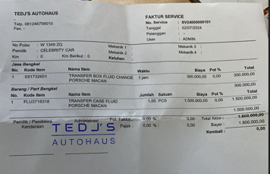Biaya Macan di Aldo
2. 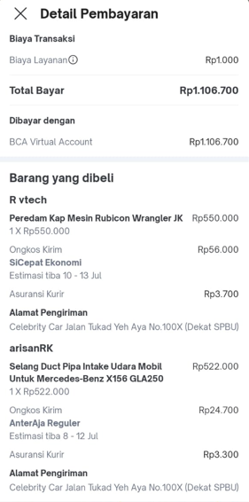Beli Selang Filter Udara GLA 200 & Peredam Kap Mesin Rubicon Merah
3. 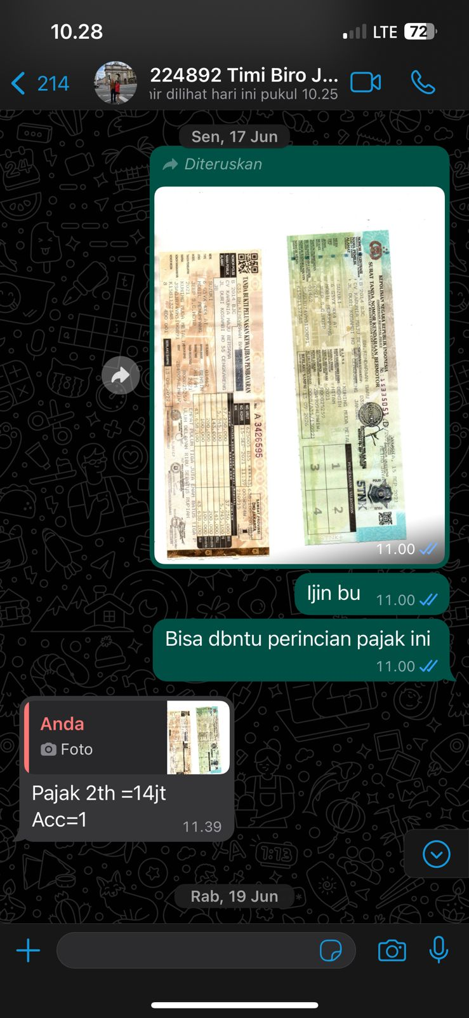Pajak Suzuki Jimny
4. Aki BMW X1

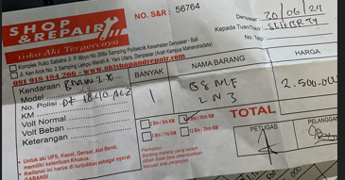

1. Towing 3 Mobil (Rubicon (5.5jt), Rubicon(5.5jt), Mazda CX(kurang lagi 3jt) via telfon)
2. Jasa Pasang Kaca Mobil FJ Cruiser (via Telfon)
3. Karet Wiper Rubicon Merah (aldo via telfon)
4. Service Porsche Cayman (aldo via telfon)